Random Forest

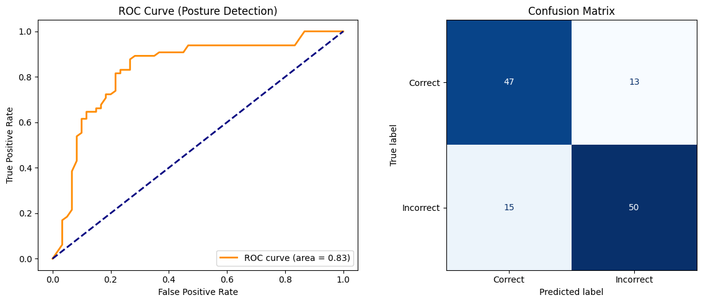

While Random Forest models do not naturally use gradient descent or have a "log loss" per epoch like XGBoost, we can visualize their performance using a Learning Curve.

XGBoost
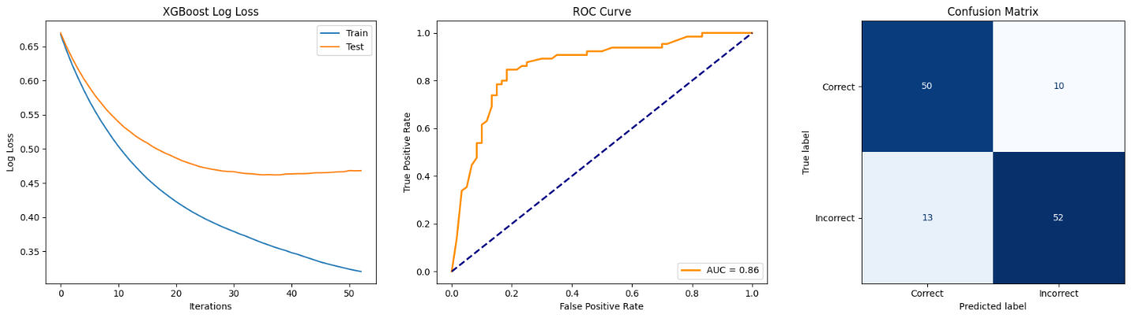

Metric | Random Forest | XGboost
ROC AUC | 0.83 | 0.86
Accuracy | ~77.6% | ~81.6%
False Positives | 13 | 10
False Negatives | 15 | 13

